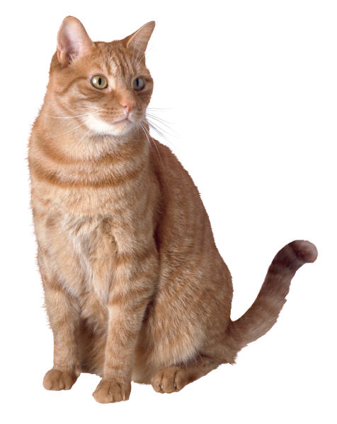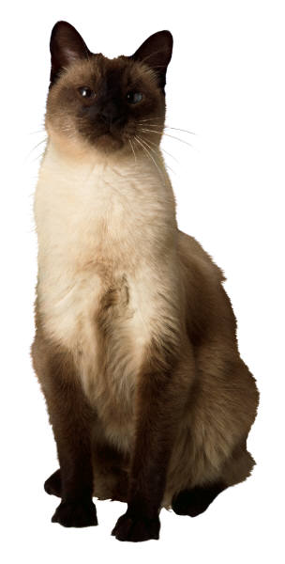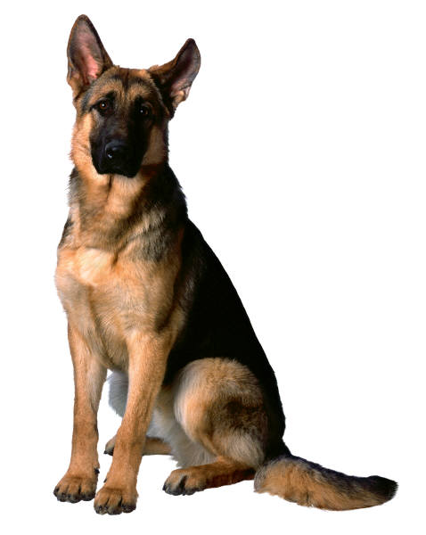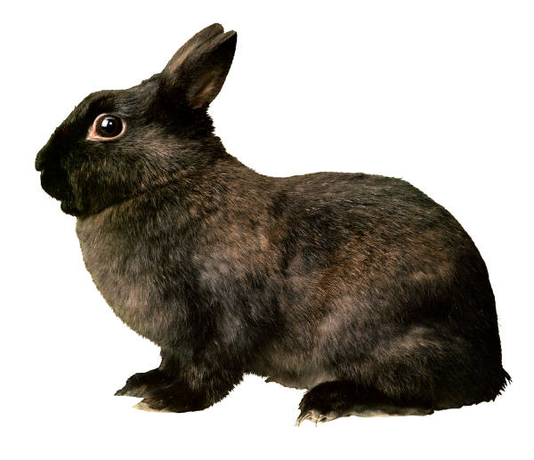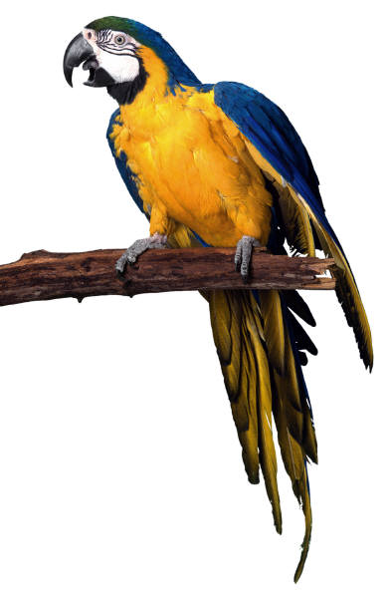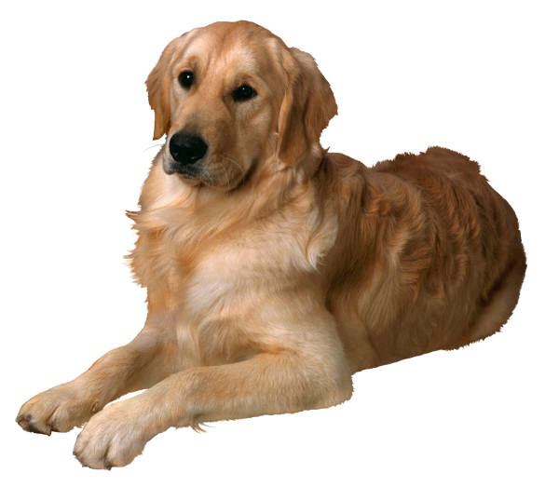

BOARDING SCHEDULE AND RATES: 2024

CHECK-IN/CHECK-OUT TIMES:

Monday - Friday - 8am – 12pm and 2:30pm – 5pm.
Saturdays - 8am – 12pm

- Late check-ins and check-outs will incur a $25.00 fee.
(incl. between 12-2)
- Day one, no matter the time of check-in, is a full day rate.
- If you pick-up your pet prior to 10:00am Monday through
Friday, you will not be charged for that day.
- Saturday pick-ups are always a ½ day charge.

WE OFFER 4 KENNEL SIZES:
Cat Suites: 3’ x 3’x 3’…….. $20.00/day
Small Dog Runs: 3’ x 5’ ………... $23.00/day
Medium Dog Runs: 3’ x 6’ ……...… $24.00/day
Our Kennels:
- Central heating and air conditioning
- Ventilation system provides fresh air at all times
- Windows provide natural daylight inside
- The kennel floors are heated
- Spacious quarters
- Fenced exercise area outside
- Separate cat suite area
- Veterinary Supervised

Large Dog Runs: 4’ x 8’ ………... $25.00/day

HOLIDAY RESERVATIONS:
(New Year’s Eve, New Year’s Day, Easter, Memorial Day, July 4th,
Labor Day, Thanksgiving, Christmas Eve, Christmas Day)

- Premium Charge……$14.50 add’l per holiday.

DAYCARE PRICES:
Daycare Small: ……………………..………$13.50/day
Daycare Med.: ………………………..…….$14.50/day
Daycare Lg……………………………..…… $15.50/day
Daycare Cat ……………………………..…..$12.50/day

***Additional boarding charges if applicable:
- Pet medication and supplements----$1.50 per medication, per administration-not to exceed $10/day.
- Fence Climbers/Jumpers that require leash walking - $10.00/day
- Dogs w/extreme dog aggression that require special handling…..$10.00/day
- Aggressive dogs that require special handling)……$10.00/day
If your dog is deemed too aggressive to handle, you will need to make arrangements to have your dog picked up.

GROOMING SERVICES: available for dogs and cats.
Grooming Prices vary depending on the size, condition and behavior of your pet.
Estimates provided upon request, however excessive Matts and/or behavior issues requiring more time… will incur additional charges.

VACCINATION REQUIREMENTS:
CANINE: Rabies, Distemper, Bordetella, Leptospirosis, Influenza H3N8, Influenza H3N2
FELINE: Rabies and Distemper

Pets should be on flea preventative. Please make sure your pet is flea free before coming in!

